

**Faculty of engineering - Shoubra**

**Benha University**

**Name: Ahmed Nashaat Mohamed Mohamed**

**B.N: 144**

**E-mail:** [**ahmed195148@feng.bu.edu.eg**](mailto:ahmed195148@feng.bu.edu.eg)

**Academic year: 2019-2020**

**Artificial Intelligence**

**Artificial Intelligence is the ability to design smart machines or develop self-learning software applications that imitate the human mind’s traits such as reasoning, problem-solving, planning, optimum decision-making, sensory Percussions. Artificial Intelligence has many applications in all fields such that: Transportation, Manufacturing. Healthcare, Finance and Banking, Agriculture-commerce, Digital Assistant, Embedded Devices.**

**There are many types of artificial intelligence, types depends on functionality such that**; **Reactive Machine, Limited Theory, Theory of Mind, Self-Aware AL. also there are types depends on cabilities such that; Artificial Narrow Intelligence ANI, Artificial General Intelligence AGI, Artificial Super Intelligence ASI. Artificial Intelligence has many advantages for example; Availability, in our daily needs, a smartphone also becomes the 4th necessity for the human along with dress, food & shelter,** **Doctors/Physician assesses the patient’s health-related data and intimates the risk factors to the customers via the health care devices with the help of artificial machine intelligence, The advantage of using Artificial Intelligence is, it helps us for error reduction and increasing the chance of reaching higher accuracy with a greater degree of precision.**

**Also Artificial Intelligence has disadvantages such that; High cost of Implementation, Risk of Unemployment, Doesn’t Improve with experience, Lacks Creativity, Can't Replace Humans.**

**Section 1 images of pages**

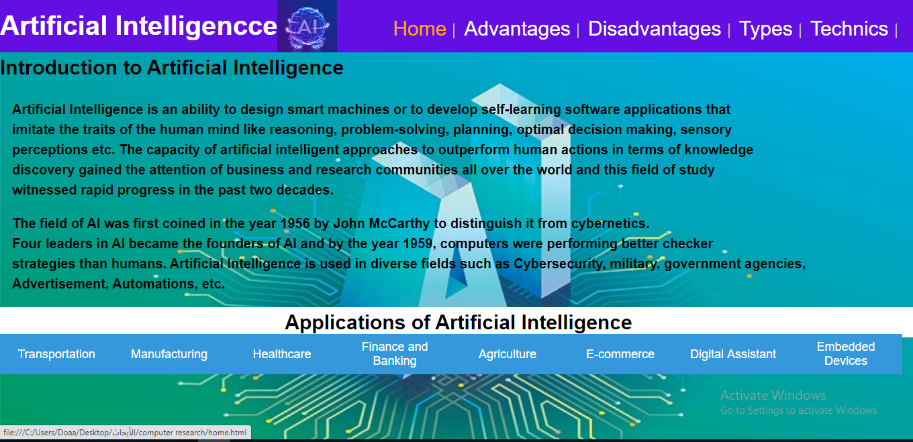

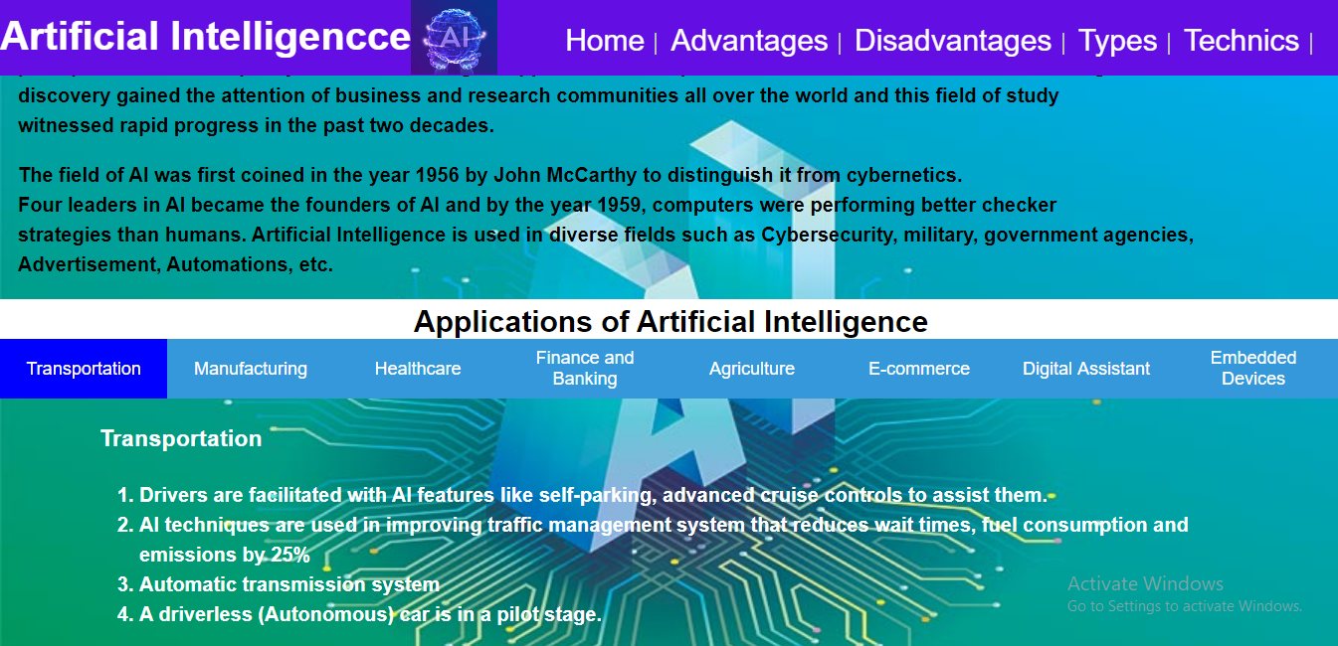**The home page**

**Tabs in the home page**

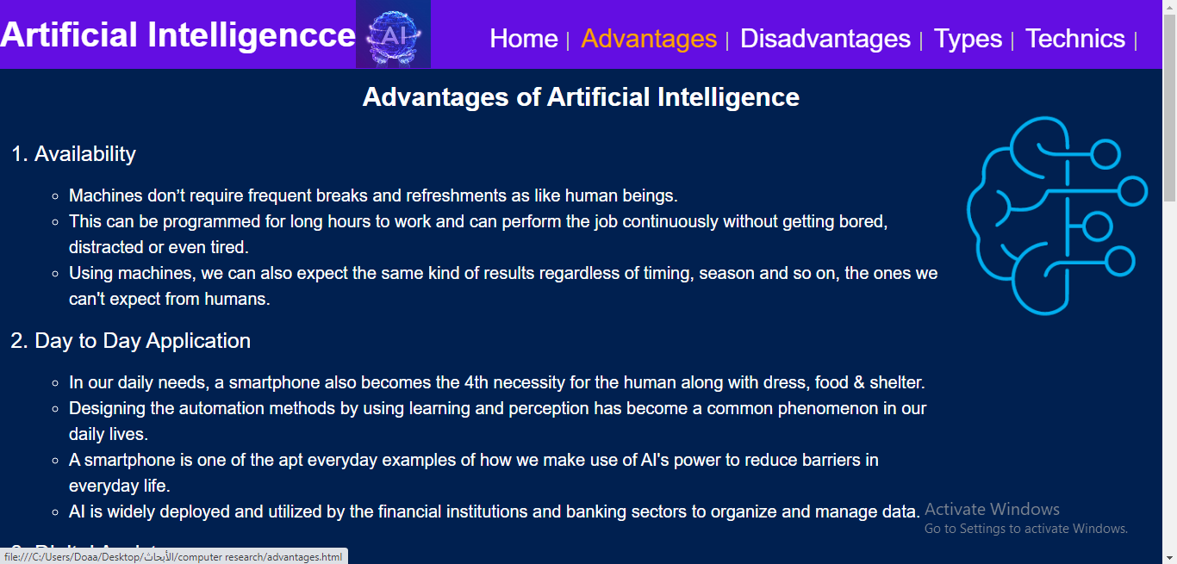

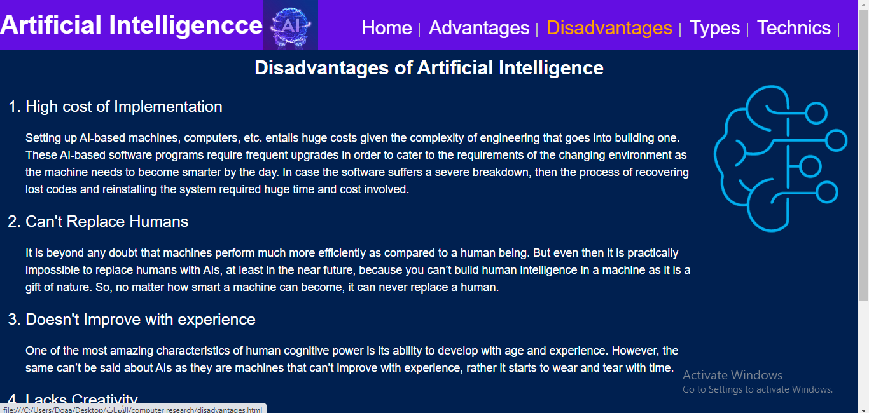**Advantages page**

**Disadvantages page**

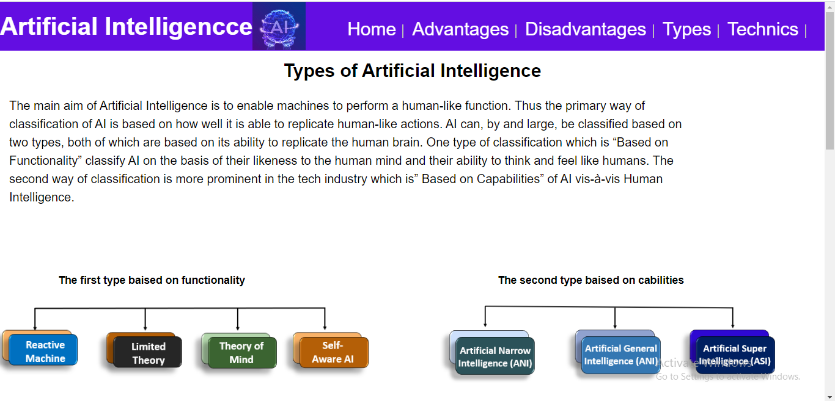

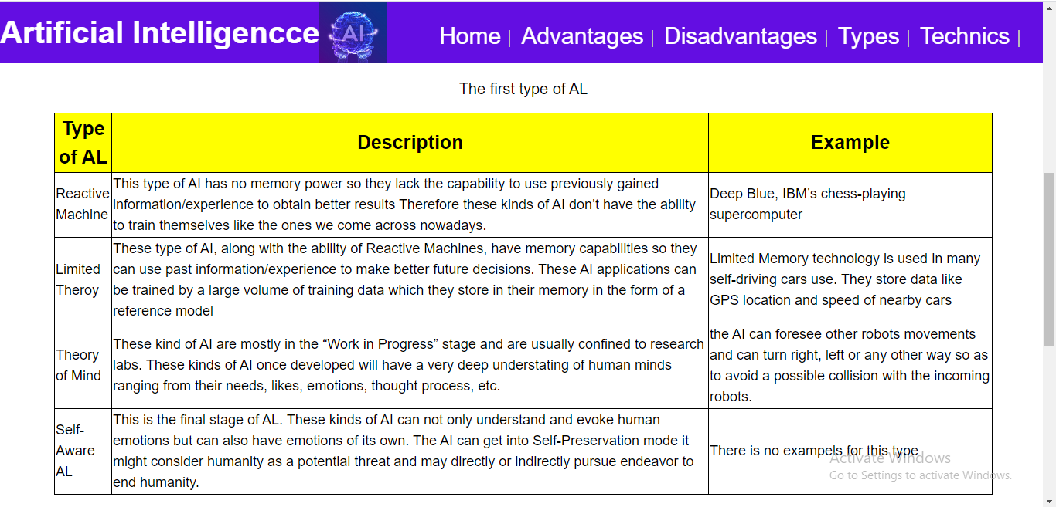 **Types page**

**Table in types page**

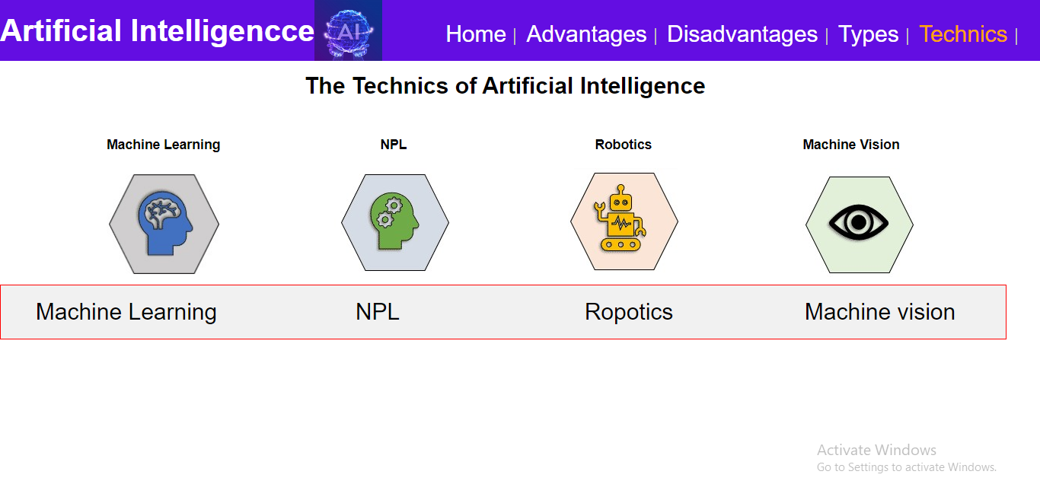

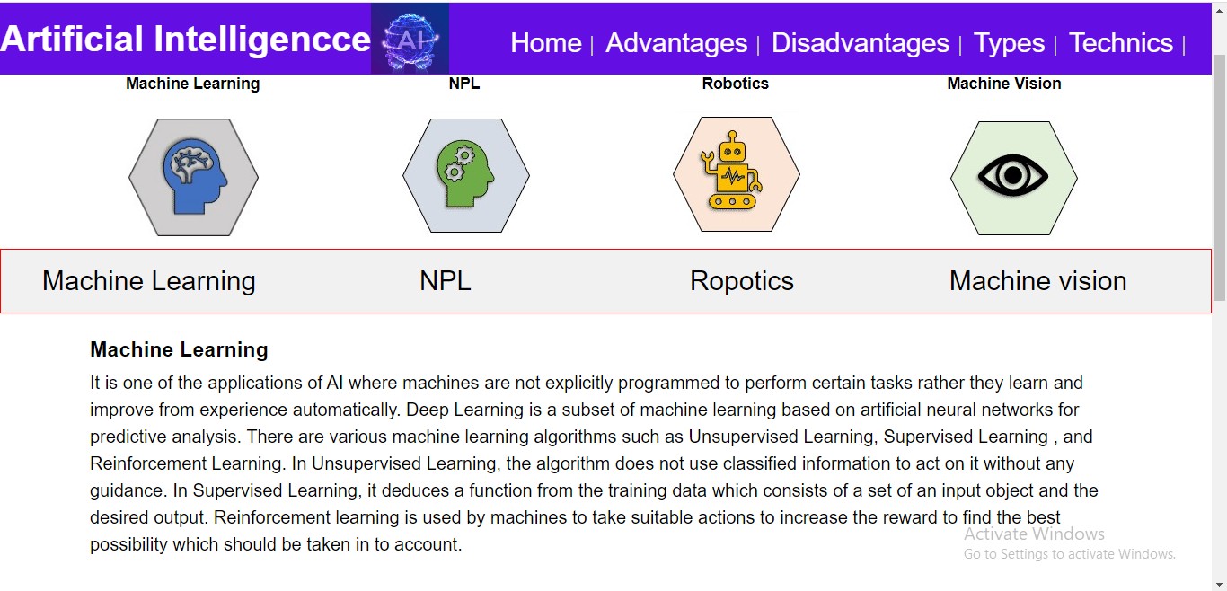**Technics page**

**Tabs in technics page**

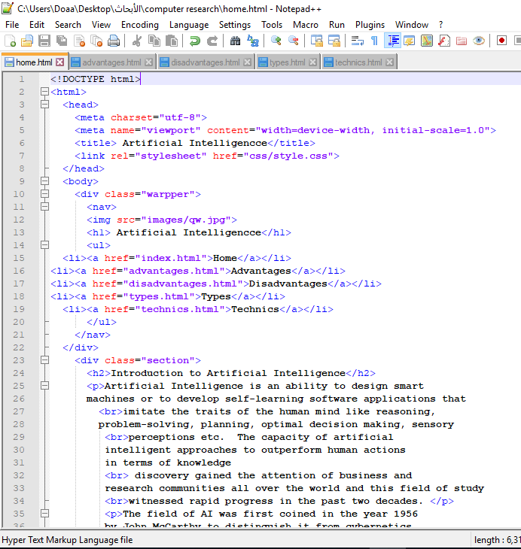

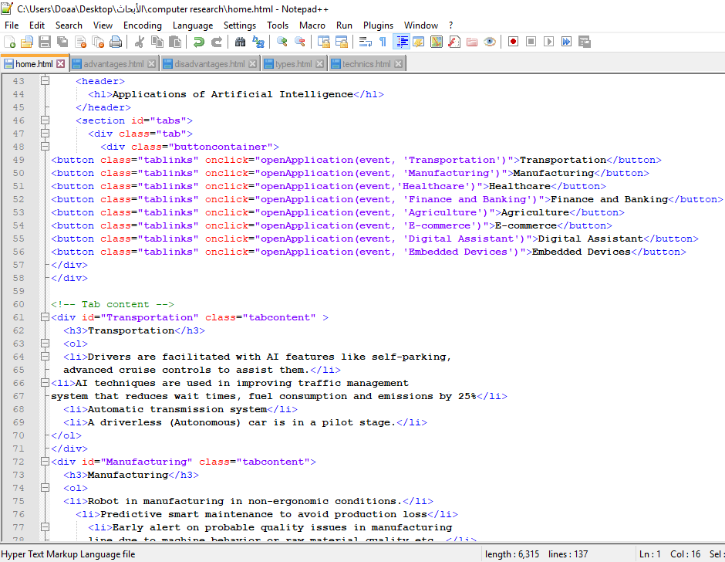Code of home page

Code of tabs in home page

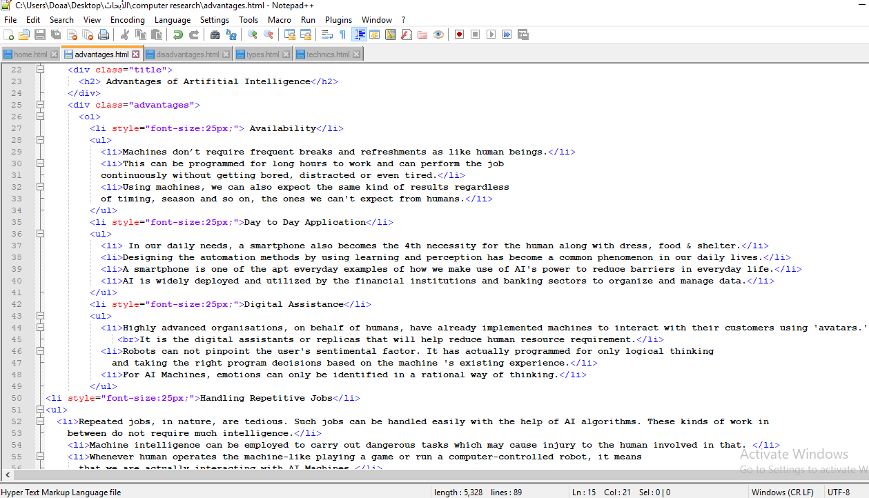

Code of advantages page

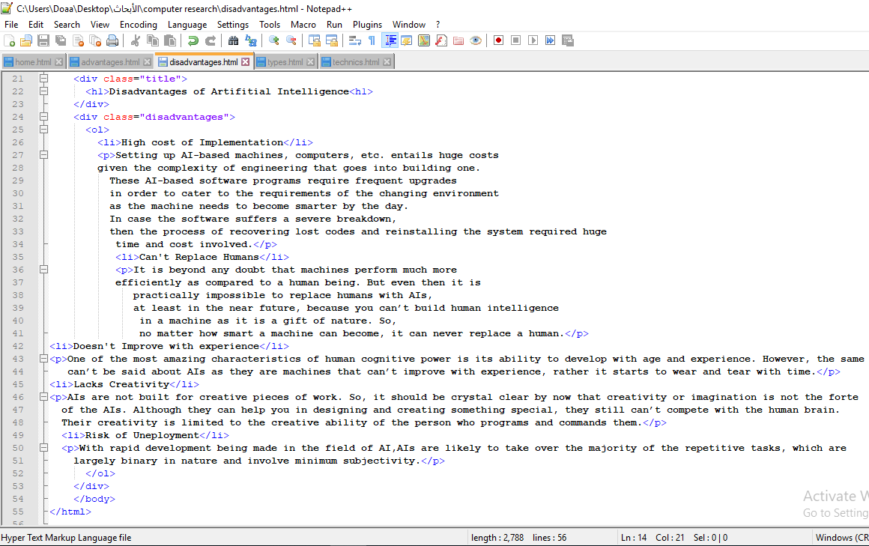

Code of

disadvantages

Page

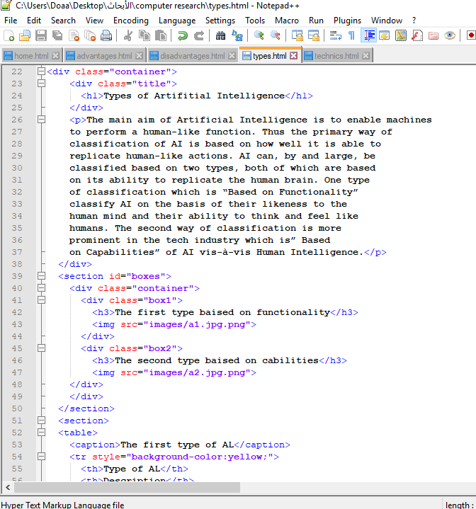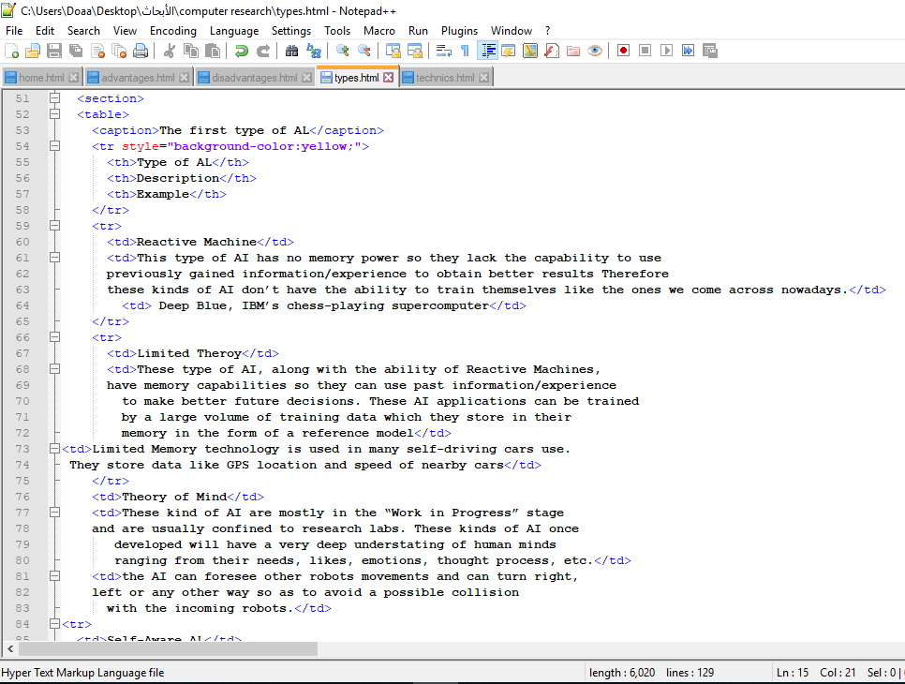

Code of types page

Code of table in types page

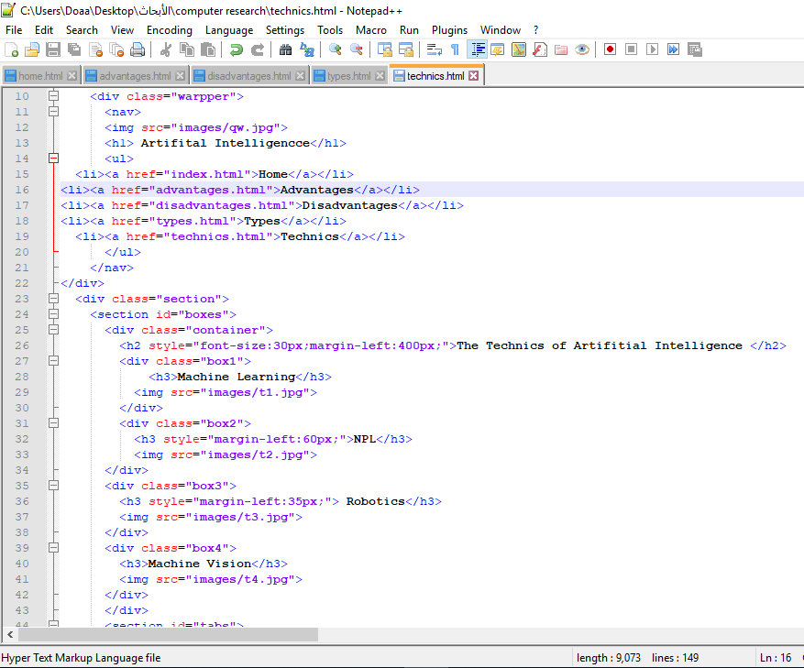

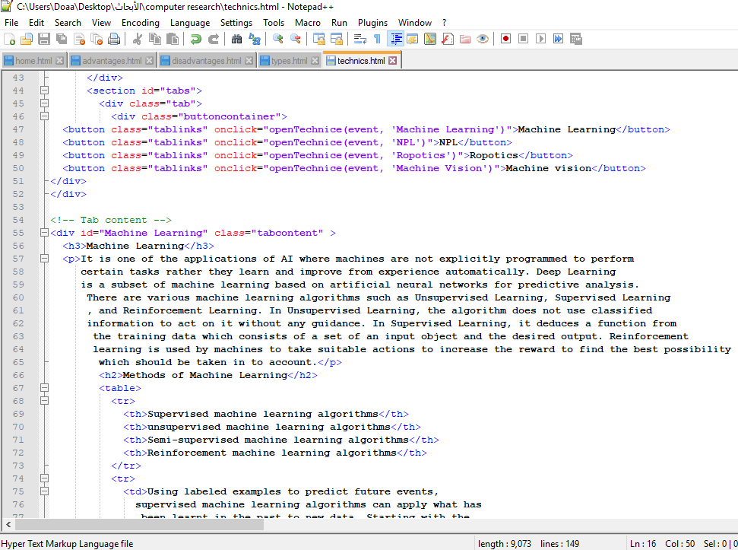Code of technics page

Code of tabs in technics page

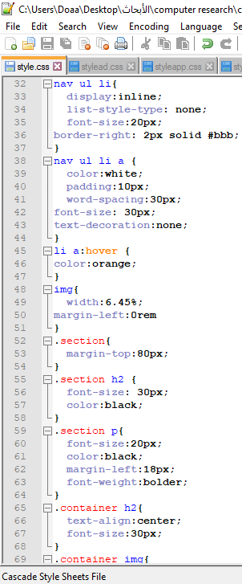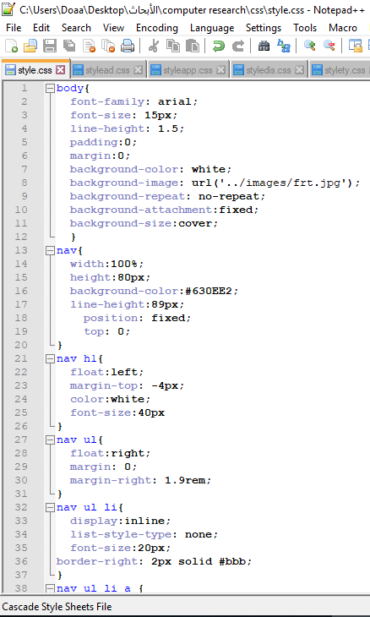

Style code of navigation style code of section (introduction)

In home page in home page

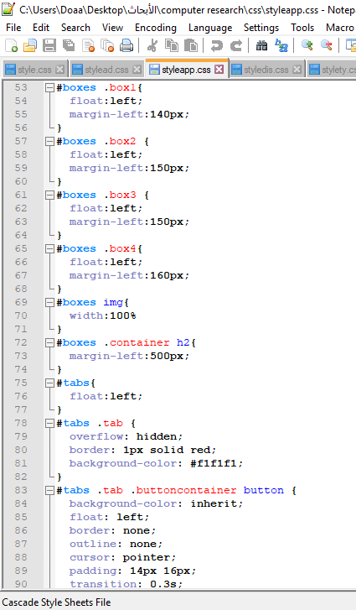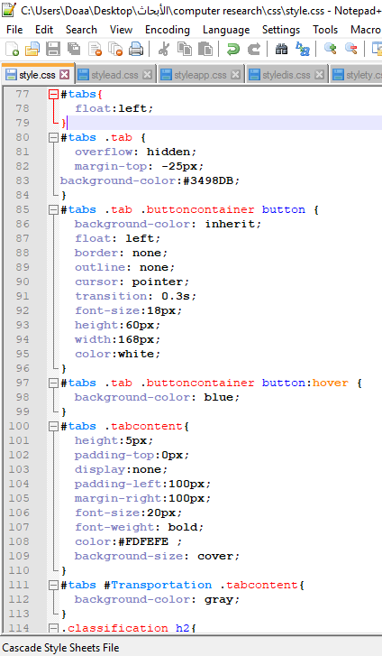

Style code of tabs style code of types

In home page page

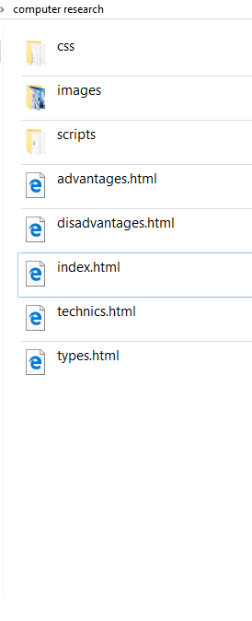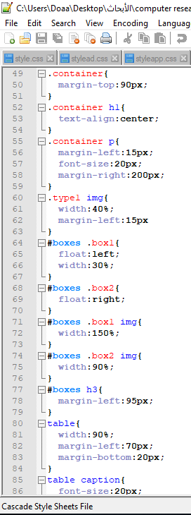

The folder of project

Style code of technics page

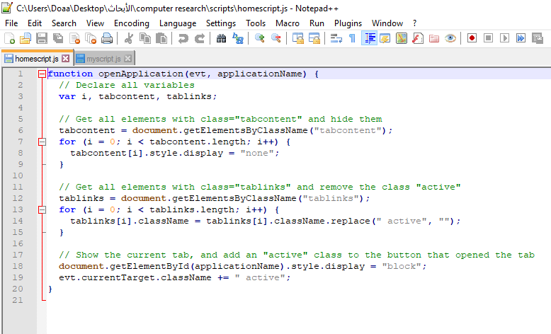 Section 4 java script codes

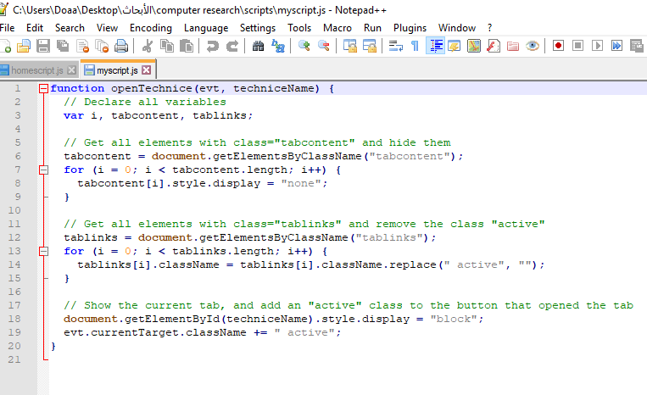 Script code of tabs in home page

Script code of tabs in technics page